Adult Faith Formation
Grow a little deeper; Reach a little higher.

See more at: AFF webpage: www.straphaels.org/adult-faith-formation

NEW FOR 2015-2016

*NEW DISCUSSION GROUPS FORMING
Monday Evenings: Stay and Pray
Rest. Reflect. Reconnect. Renew. You're worth it!
Beginning September 28 and continuing on Mondays 7:00-8:15 PM in the All Purpose Room when RE is in Session.
Prayer: Facilitated Lectio divina will bring new insights to the Scripture readings of the coming Sunday.
Discussion: This Fall's topic: What, when, and how can we share with our children “Top Ten Takeaways" from Laudato Si, Pope Francis’s encyclical on the environment.
http://americamagazine.org/top-ten-takeaways-laudato-si
Please email Laure Quesnel for more information at lmquesnel@gmail.com

*NEW MORNING AND EVENING BIBLE STUDIES
Tuesday Mornings: Matthew: The King and His Kingdom
Matthew: The King and His Kingdom is a Catholic Bible study that brings the Gospel of Matthew to life and draws us closer to Christ. We will see Jesus as the awaited Messiah who fulfills the promises and prophecies of the Old Testament, establishes the New Law and inaugurates the Kingdom of Heaven. We will learn what his life and teachings mean for us today.

Join us for Matthew: The King and His Kingdom in the Parish Library on Tuesday, September 8, 2015 at 9:45 a.m. and continuing from 10-12 every Tuesday until Advent. After Christmas, the study will resume from January through April. For more information and to register, call Dorothy Welsh 301-526-5779 or email dwwelsh5@aol.com. Individual orders of the study set can be placed with Ascension Press at www.biblestudyforcatholics.com or by calling 800-376-0520.

Thursday Evenings: Revelation
Join us for Revelation: The Kingdom Yet to Come, a reading, discussion, and video-based Bible study by Jeff Cavins. See how Christ’s kingdom in his Church, the kingdom of heaven, and the Eucharist are intimately connected. Learn what the mysterious figures and images symbolize, what will happen during the Second Coming of Christ, what has already happened, and what is happening now in salvation history.
The 11-week study begins September 10 at 7:30 PM in the Duffy Center.
Please order your study kit from Ascension Press (1-800-376-0520) for $25 (+ postage).
To register and for further information, please email Suzanne Nelson at ptmcenter@aol.com

*NEW ADVENT AND LENTEN PROGRAMS

Wednesday Evenings in Advent: Falling Upward: A Spirituality for the Two Halves of Life
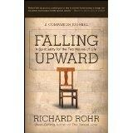
A Richard Rohr Seminar led by parishioner, Sally McClean, adjunct professor of English at Montgomery College. All are invited. Two books are needed: Falling Upward: A Spirituality for the Two Halves of Life and Falling Upward: A Spirituality for the Two Halves of Life – A Companion Journal. They can be ordered through Amazon.
Save the dates: Dec. 2, 9, 16 --- 7:30-9:00 PM in the Parish Library.
Email Sally to register or for more information: smcclean@comcast.net

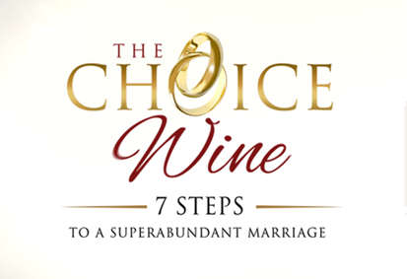Tuesday Evenings in Lent and Eastertime:

This brand new “couples program” is from the producers of the eminently successful STR program “That Man is You.” Explore seven well researched, relevant spiritual topics designed to fire up game- changing conversations among coupled participants. Save Tuesday nights for CW, beginning on February 2, 2016, 7:00-9:00 PM, and running thru the Easter Season.
To get more information or to register please contact Gerry and Jackie Murphy at jackie.choicewine@gmail.com

…and more to come….

